Camera speed data 19th November 23 – 19th December 23

School Camera
Total vehicles seen (both directions) – 38,145.
Vehicles travelling into the village.
84.36% of vehicles travelled at 30mph or less.

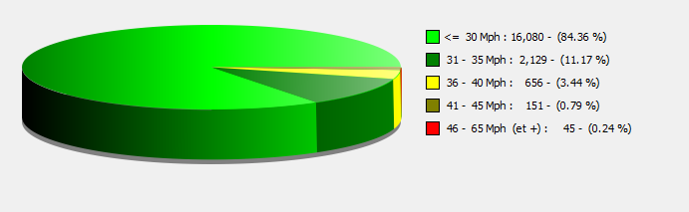

Greatford Road
Total vehicles seen (both directions) – 23,776.
Vehicles travelling into the village
88.43% of vehicles travelled at 30 mph or less. Compliance on the exit from the village is a lot worse with only 75% of vehicles sticking to the 30mph limit.
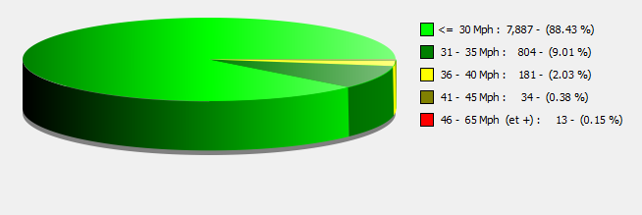

Main Street
Total vehicles seen (both directions) – 83,414.
Vehicles travelling into the village.
95.14% of vehicles travelled at 30 mph or less.
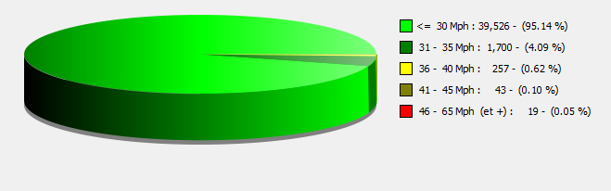

A15 Camera
Total vehicles seen entering the village – 189,742.
99.41% of vehicles travelled at 40mph or less.
