

**AUTUMN 2024 NEWSLETTER**

**ISSUE 1**

**VIEW FROM THE CHAIR**

We hope to publish two Newsletters a year to keep you in touch with what we are up to.

This has been a busy year for the committee; the previous Chair stepped down recently. The role is currently being shared. New members have joined us and we are hoping in the near future to co-opt more members onto the committee.

The focus of our recent activities has been to raise awareness among the patient community of the PPG and its role, which is to act as a channel between patients and the practice. It must be stressed however that we are unable to get involved in any personal issues which should be taken to the Practice Manager or a member of the medical staff.

**Important information from the practice**

**FLU / COVID Vaccination bookings**.

The practice are busy booking eligible patients in for their flu / covid vaccinations during October. They are offering Saturday appointments for flu vaccinations only and weekday appointments for flu and/or covid vaccinations. Eligible patients with a smart phone have been sent links to book their appointments online, alternatively please contact the practice on 01778 579000 or visit the front desk at either the Market Deeping or Glinton surgery.

**Why is it extremely important to have your vaccinations administered at the surgery?**

Our clinicians have direct access to your health records. We ensure it is safe to administer, looking at any possible allergies you may have, and dates of previous vaccinations. We can ensure you are eligible. We may also be able to offer you other vaccinations at this appointment (Pneumococcal / shingles etc).

**A DAY IN THE LIFE OF**

**The Deepings Practice Manager**

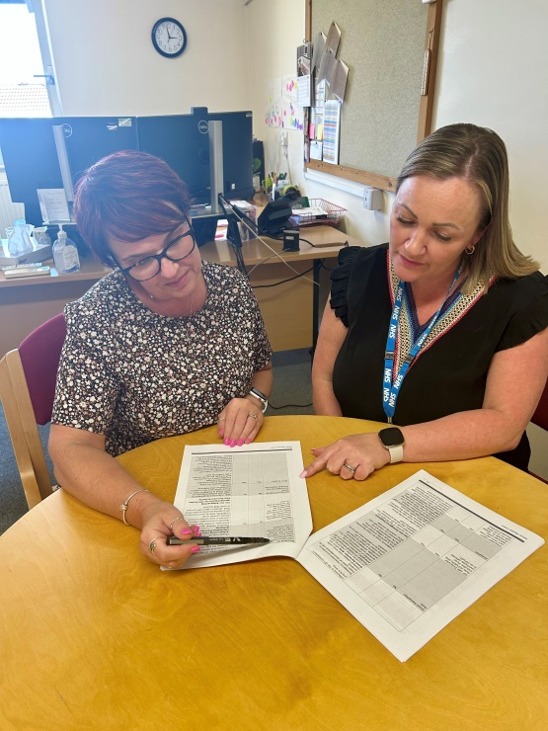4.7.2024.

Wake up at 05:45 get ready for work arriving at 7AM. This is at least 30 minutes of time I have before staff start arriving and then dealing with all sorts of situations. I look at urgent things that need doing and hope by the end of the day I have ticked these off.

At the time of writing this I am dealing with staff and covid, so we need to ensure all staff are safe all of them have testing kits and nobody is in the building with covid. Then looking at how we can ensure we deliver appointments due to lack of staff. I am also planning the winter flu and covid programme which this year has been pushed back a month to October, this is a shame as we had early delivery, so we are not competing with the pharmacies as we have ordered the stock to give to our patients.

I am booking bank nurses to be able to give the vaccinations, so we do not lose out on general appointments with our nurses for the day-to-day appointments we need to offer. Today I am also planning the next Business Meeting with the partners, this is where we review anything that is new or services that need reviewing. We need to ensure that any service we offer we can provide without making a loss, like any business that would do something that puts them in arears.

I have written an appraisal due next week; met with my practice chair to review anything I think is important and plan the next meetings with partners. Had catch ups with my management team with any issues they may have, had a general walk round to staff. Read a report ready for a meeting Monday with a PPG member (patient group). Reviewed the new insurance policy and looked at getting other quotes with a deadline of a few days – they never give you enough time.

The number of conversations I have in one day is astounding, but needed to help all my team deliver the best they can. Without this team I would not be able to do this job, every member of the team is integral to the workings of the practice, and I appreciate and value them more than they know. There is so much more but I only had a small space in the newsletter 😊

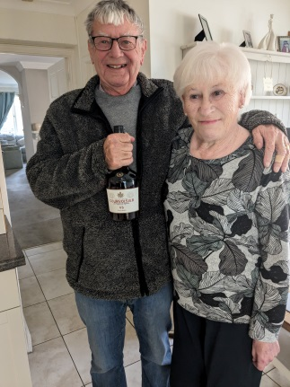**RETIRING FROM HIS POST AS VOLUNTEER DRIVERS' COORDINATOR**

**ALAN MCKIE**

Alan was presented with his favourite tipple by the PPG for his dedication to the role of coordinator for the Voluntary Drivers’ scheme which is operated in Deeping and organised by the PPG coordinators in conjunction with the Deepings Practice.

**MORE FROM THE VOLUNTARY DRIVERS**

On July 2nd the PPG and three members of the Deepings’ Practice attended an informal buffet at The Deepings Sports and Social Club. Dr Phipps gave a vote of thanks to the drivers and coordinators. A raffle was drawn and the winner’s prize was an M.O.T. Courtesy of Towngate Tyres.

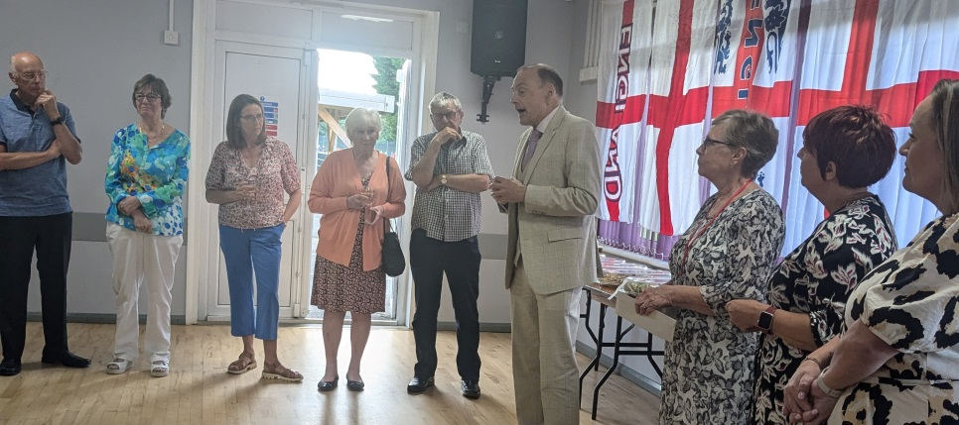

Dr Phipps giving the vote of thanks

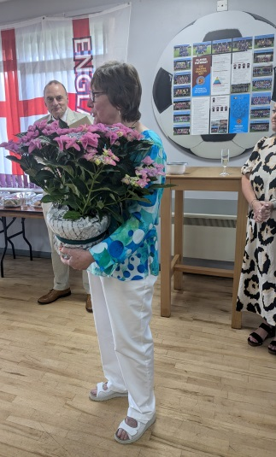

Lyn Thompson was presented with a beautiful hydrangea. She is the lead coordinator who stepped in at short notice last year after Alan retired. It is a very responsible job having to liaise with the Lincolnshire County Council on driver vetting.

Other coordinators are Kevin Daly & Jim Torrance who along with Lyn rotate the coordinator’s roll on a weekly basis.

**FUND RAISING**

Throughout the spring we have been raising funds for the Voluntary Drivers’ Evening. Here are some photos from various events:

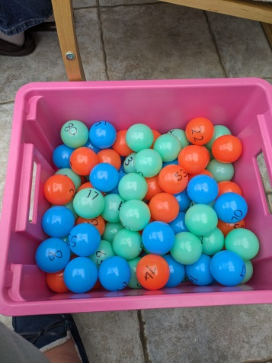 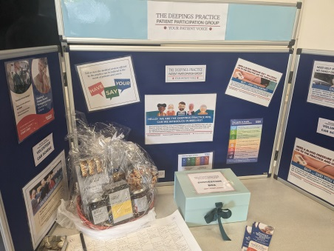 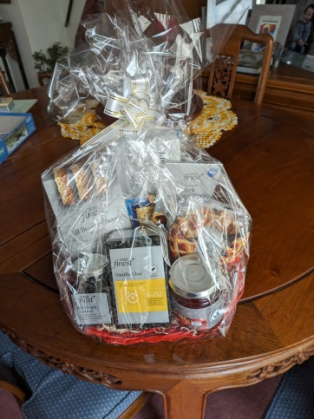

We are very grateful to Tesco for their hamper donation and to the following businesses in Deeping that have helped us provide the excellent Raffle/Tombola prizes:

Café Mills, Scissors Studio, Manna Flowers, Paper Kisse Card Shop, Boundary Fish and Chips, Pet Stop and the many other individuals who donated items.

**LIBERTY PARTNERSHIP PRESENTATION**

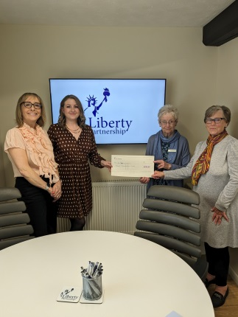Our first sponsors, Liberty Partnership who provide Financial Advisory Services in Market Deeping, presented a cheque to the PPG Treasurer and PPG member in April. We are extremely grateful to them for their generous donation which will help us with our funds.

**DO YOU KNOW WHERE TO GO IF YOU REQUIRE MEDICAL HELP?**

It can be a worrying time if you are not well and can’t decide the best course of action. Obviously, in an EMERGENCY WHERE LIFE COULD BE AT RISK you would ring 999. However, your next port of call would be the 111 service. They will direct you to the most suitable place for your condition.

Below, there is a chart showing where you would be directed to for an appointment.

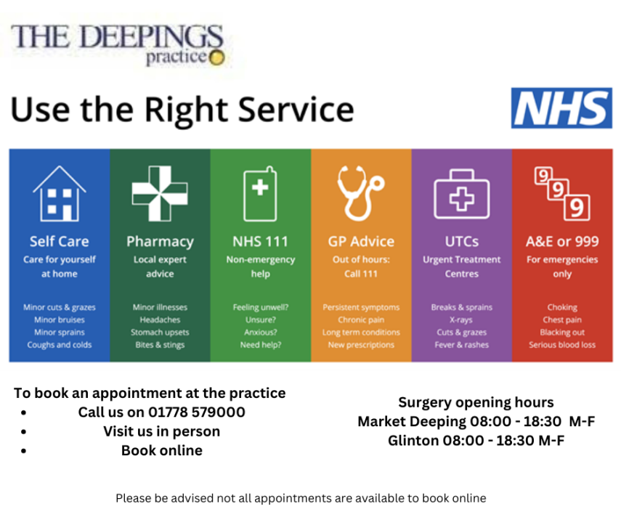

There is a really useful online App which is gives you the locations and waiting times for English Urgent Treatment Centres and Pharmacies by location or Post Code. This is called **WaitLess.**

**WaitLess APP logo.** [WaitLess Web (e-waitless.com)](https://e-waitless.com/)

**HEALTH TALKS**

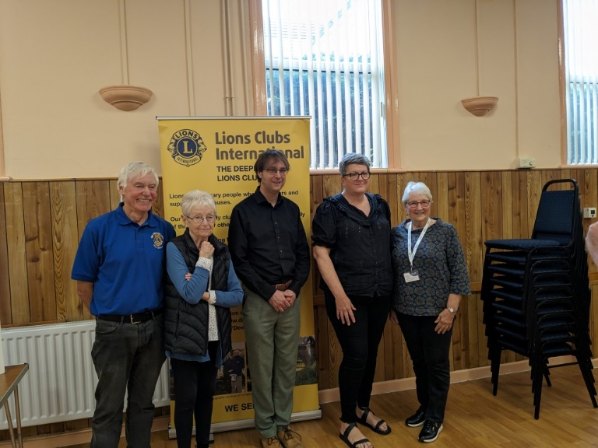

In May, The Lions, a Charity Group from The Deepings, held two Health Awareness events.

One was about Bowel Cancer, the other information relating to Dementia.

The photo shows Dr Wade, who presented both events along with a member from the Dementia awareness group, Jo a Social Prescriber, A member of the PPG and also the Chair of the Lions Group. The PPG helped with refreshments on both occasions.

**YOUNG PEOPLE AND THEIR INPUT INTO THE PPG**



This year we have been encouraged by the attendance at our meetings, by a group of students from the 6th form at The Deepings School. All four intend to go into some form of NHS work. The group were joined by two 6th form students from Bourne Grammar. Joining the group gives them an insight into patient participation.

The Deeping Students organised their own survey relating to how many of their peer group knew about the Practice and services that were available to them. The results were shared with the Practice Manager for future planning.

**ARE YOU RECENTLY RETIRED AND WONDERING WHAT TO DO WITH YOUR TIME?**

You could:

Become a Volunteer Driver/Coordinator. Tel: **07858373912**

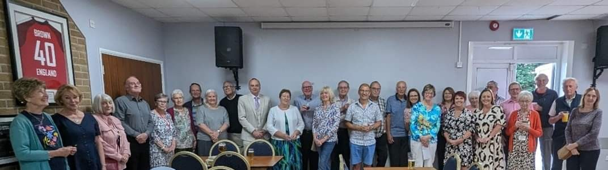

*Above are the volunteers that either drive, coordinate or support the Voluntary Drivers*

Join the PPG contact [secretary@thedeepingspracticeppg.org](mailto:secretary@thedeepingspracticeppg.org)

Join the U3A. This stands for University of the Third Age.

[Deepings u3a: Welcome u3asites.org.uk](https://u3asites.org.uk/deepings/welcome)

There are groups for all manner of tastes. Walking, Cycling, Art, History and Crafts just to mention a few. Details can be obtained from the Library and Community Centre

OR

You could:

Volunteer at the Deepings Library

Help at the Community Centre

These are just five things on offer but if you call in to either the Library or Community Centre there are lots of leaflets to help you choose a hobby or pastime.

**What is Social Prescribing?**

It all starts with a conversation

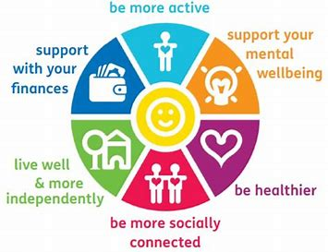

Referrals to social prescribing can be made via the GP, Reception or you can self-refer via [licb.socialprescribing.slr@nhs.net](mailto:licb.socialprescribing.slr@nhs.net)

**HAVE YOU EVER TRIED?**

**REFLEXOLOGY**

Reflexology is a holistic treatment, where pressure is applied to specific areas on the feet, to bring about a sense of wellbeing. The principle behind Reflexology is similar to acupuncture, but without needles. Reflexology aims to bring about relaxation and assist the body’s healing processes.

Helen has been a Reflexologist for 20 years and has a treatment room at Deepings Community Centre.

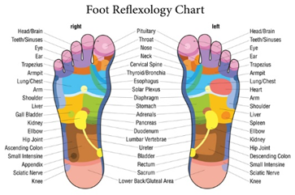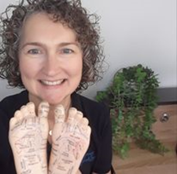

We Hope you have enjoyed reading the first edition of

**The PPG NEWSLETTER**.

If you would like to contribute an article for our next newsletter, or require further information please contact the PPG at [secretary@thedeepingsppg.org](mailto:secretary@thedeepingsppg.org)

During this year we have:

* Made contact with all the local parish councils
* Supported the medical team with the vaccination programs
* Attended local medical information events
* Obtained sponsorship to support the Voluntary Drivers’ Scheme
* Raised funds for Drivers’ appreciation evening
* Submitted articles for the local village magazines
* Made contact with the sixth forms of the local secondary schools

We would not have been able to do any of the above without the help of the following

The PPG WOULD LIKE TO THANK:

The Deepings Practice for their help with printing and distributing of the Newsletter.

Liberty Partnership for their sponsorship.

Tesco Store Market Deeping for the donation of a hamper.

The Vine Public House for the use of their meeting room.

Towngate Tyres for the lovely raffle prize.

The Deeping Community Centre for allowing us to use their advertising screens.

The Grapevine Magazine for accepting our articles for publication.

The Village Tribune for giving us publicity

Deeping Lions who invited us to their well-being events.

The generous business community of The Deepings who provided raffle prizes

Deeping Sports and Social Club for letting us use their facilities.

The anonymous donor who helped to fund the drivers’ evening.

Apologies if we have forgotten to include your contribution to our fundraising this year. Without your kind donations our events it would have been much harder to achieve success.